**1.Introduction**

Driver drowsiness or driver fatigue has main issue which causes the main for increasing the accidents. The main reason behind the driver drowsiness is the not taking the proper sleep before the long driving as well as other reasons for untreated sleep module, medical, drinking alcohol , smoking which affects as well as affects the health of person which indirectly affects the sleep of the person. According to the various articles as well as the National Highway Traffic safety administration around 40% accidents are due to the driver drowsiness detection. The accidents caused to the drowsiness are increasing day by day due to the bad habits as well as less sleep which causes the fatigue. The system is detecting the driver drowsiness using the image processing as well as yawn detection because drowsiness state and the yawing both are different. If the driver is to be found in the drowsiness state then the alert system comes in act to send the email or alert message to the respective person with the location to avoid the causalities

**1.1 Problem Definition:-**

Drivers Drowsiness Detection and alert System by Measuring EAR

**1.2 Goals and Objectives:-**

1.To enrich Ourself with the various Drowsiness Detection Model.

2. To present a comparative study of various Drowsiness Detection Model.

3.Using the SMTP to send the Email

4.GPS module to finding the location

**1.3 Motivation:-**

Driver drowsiness is significant reason in increasing number of accidents on roads. If the data of road accidents in India only consider which shows that more than 20% of all road accident victims are found going through sleep disorders. So it shows the importance of research with objective to reduce the danger of accident due to drowsiness. Current systems are working on crating link between drowsiness and certain indicator related to driver and vehicle.

The previous approaches to drowsiness detection make pre-assumption about the EAR ratio, blink rate etc. Several business also has tried to build several system to predict driver drowsiness but only few commercial product are available today. Naturally, most people drive differently so it is necessary to create a system which can work with high accuracy in any conditions. So our motivation is that creating system which will able to adapt changes in driver or conditions with high accuracy rate.

**1.4 Scope of work:-**

Creating a system that will be able to detect the drowsiness of the person with the great accuracy. In the early stages there are limitation to the detection of the drowsiness due to the various factors such as the if a person is wearing the spectacles the detection of the drowsiness is not accurate in the future trying to increase the accuracy of the detection. The system will be in the use in normal when it has the greater accuracy to increase the accuracy it should be adoptable in the night as well because there is a high chance of the person to get drowsiness at the night. The camera with the high quality as well as night detection with the higher accuracy with makes the work easy of the image processing with the greater accuracy.

**1.5 Outcomes:-**

A purposed system can be able to detect the drowsiness with the higher accuracy and able to send the alert message to the respective person in a real quick time. The application of the these is very beneficial in the real time to avoid the accidents and the purposed system is with less amount with great accuracy.

**2. Literature Survey**

**2.1 Summary of Literature Review:-**

[1] M Arunasalam , N Yaakob , A.Amir , M Elshaikh and F Azahar “Real time driver drowsiness detection with alert notification”

The author purposed that if the car is stopped at some place due to the detection of drowsiness the GPS will be getting activated and it will send the location of that particular place where is the car is being is stopped and the a GSM model is used to send the message that includes the warning message related to the drowsiness and the location of place.

[2] Anil Kumar Diswal , Debabrata Singh ,Binod Kumar Pattanayak ,Debabrata Samanta “Detection the fatigue of the person with the help of IOT module”

In these paper author purposed that when the EAR value goes about any certain frequency that is being set then the alert Email is send to the authorised person or the person which is being mentioned and the alarm will be start ringing in the car. To perform the Email sending the smtp library is used which is available in the python.

[3]Debasis Parida “An Ardunio based Driver drowsiness and alerting system”

In these paper the writer says that a specific is used to count the blink eyes and if the blink eyes are more than the some limited specified value then the alarm start ringing until the driver comes completely out of the drowsiness state. They performed the alarm system with the help of the eye blink count.

[4] Ismail Nasari, Mohammed Karrouchi “A Review on the driver drowsiness and alert system”

A frequency is the measured, a condition related to the frequency is created that if the frequency is greater than 50 then the driver is in not in the drowsiness and the if it is less than the 50 then the driver is in the drowsiness state then the alert message is send to the respective person and the alarm starts ring.

[5]L. Ramesh*, M. Monisha, A. Shirley Pradeeksha, P. Sowmiyaa, S.K. Vedhashre **“**Driver drowsiness monitoring and Alarming”

This paper purposes that the they are measuring the drowsiness of the driver with help of the signals , it is very delicate and sensitive system which detects the movements of the steering wheel of the driver and if finds out it faulty then it activates the alarm system.

**Common findings from Literature review:**-

Common things from the literature review are that the most of the papers are using the an alert system which mostly consists of sending the alert Gmail or message as well as the ringing the alarm.

**3.Algorithmic Survey**

**3.1 Study of Algorithms:**

1. Information about the GSM module to send the message:-

In these methodology a GSM module is used to send the messages which uses the AT command to perform the various operations such as the sending the messages , making the phone calls and connecting to the internet. Every GSM module comes with the AT commands with manual.

AT commands to perform the message sending is as follows:-

AT+CMGF=-1 this is used to set the SMS format to text mode.

2. Sending out the Email with the help of the smtp library with the help of python:-

SMTP has the full form Simple Mail Transfer Protocol which performs the functions sending email and routing email between the servers. The python has the smtp library which consists the object that it is useful to send the mail to the any devices with the help of the internet. An smtp library has the object named as the send which is typically used to do the working of the message. It consists of the three parameters as follows:-

1. The sender which is the string and consists of the address of the sender.
2. The receivers is the another parameter which is the address of the recipient.
3. The message parameter which is generally consists of the message which is we want to send to the receiver.

**3.2 Algorithm steps:**

if(ear_ratio<thershold value)

{

Excutes the code for the Email sending and the alarm begins to ring.

import smtplib;

sender=’from@fromdomain.com’

receivers=[‘to@domain.com’]

message “ from.from person [from@fromdomain.com](mailto:FROM@FROMDOMAIN.COM)

to:to person [to@todomain.com](mailto:TO@TODOMAIN.COM)

subject: smtp e mail test

this is a test a email message

}

else

{

Do not ring the alarm.

}

**3.3 Motivation to develop proposed system:-**

As per the variety of reports the road accidents percentage is increasing day by day. There are various reasons behind the road accidents , but the most percentage of the accidents are happening due to the drowsiness. The drowsiness state of the driver is generally at the night , there are many reasons behind the drowsiness such as improper sleep , bad health habits such as smoking , alcohol which affects the sleep. To avoid the accidents due to the drowsiness we are designing the system that will ensure to avoid the road accidents.

The system can be very beneficial to avoid the accidents which are happening to due to the drowsiness. These system will be also send the alert notification as well as the location of the person as soon as it locates the drowsiness. It consists of the alarm ringing facility also to alert the driver.

1. **Proposed System**

**4.1 Introduction:-**

Driver drowsiness or driver fatigue has main issue which causes the main for increasing the accidents. The main reason behind the driver drowsiness is the not taking the proper sleep before the long driving as well as other reasons for untreated sleep module, medical, drinking alcohol , smoking which affects as well as affects the health of person which indirectly affects the sleep of the person. According to the various articles as well as the National Highway Traffic safety administration around 40% accidents are due to the driver drowsiness detection. The accidents caused to the drowsiness are increasing day by day due to the bad habits as well as less sleep which causes the fatigue. The system is detecting the driver drowsiness using the image processing as well as yawn detection because drowsiness state and the yawing both are different. If the driver is to be found in the drowsiness state then the alert system comes in act to send the email or alert message to the respective person with the location to avoid the causalities. The third class consists of methods based on motive force’s overall performance, which monitor vehicle behavior such as shifting direction, steering angle, velocity, braking, and so forth. eventually, the fourth class combines techniques from the above cited three classes. The laptop imaginative and prescient based techniques from the second class are mainly effective, because the drowsiness can be detected via watching the facial functions and visible bio-conduct along with head position, gaze, eye openness, eyelid actions, and mouth openness. Proposed set of rules is based totally on pc vision approach. the main awareness is at the detection of blinks by estimating the EAR(Eye element Ratio).

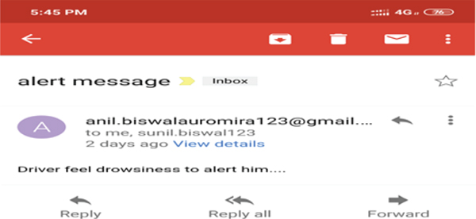

**Figure 1. Alert Email**

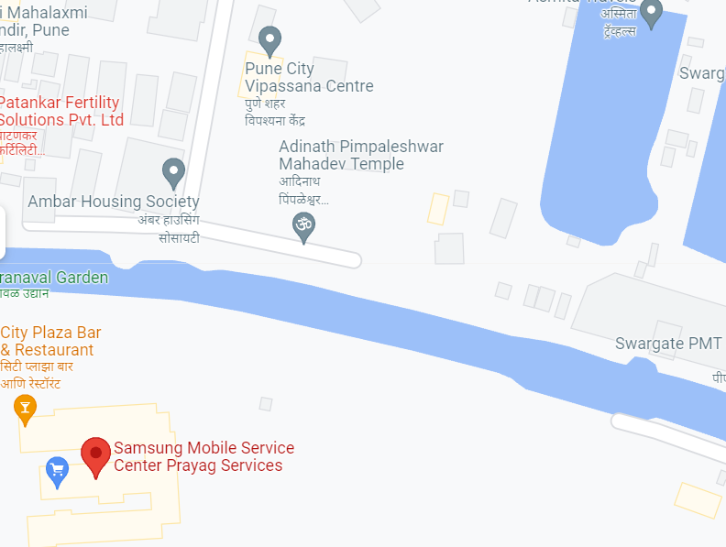

**Figure 2.Location of drowsiness**

**4.2 Proposed architecture/ system diagram:-**

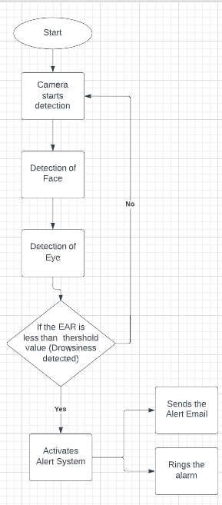

**Figure 3.Algorithmic Flowchart**

**4.3 Proposed Approach / Plan of activation:-**

The first thing is to have the high quality camera which can be able to detect the face as well as the eye detection of the driver in any situation to calculate both EAR ratio and the yawn detection. EAR ratio is being calculated with the help of the Infrared camera and Dib library is used to assigning 68 landmarks to face which are useful to calculating EAR. After this SVM(Support Vector Machine) trained with dataset which is used to only extract eye landmarks from all facial landmarks. By using the mathematical formula ,EAR ratio is calculated by calculating horizontal distance and vertical distance between eye. After the calculating the EAR ratio if these value is greater than the threshold set value then the alert system will be activated that will send an alert email as well as starts to ring the alarm. For sending alert email the smtp library is used which is available in the python as well as we are using the GPS module to keep track of the location of the driver. The alert will include the alert message with the location of the driver.

**5. Comparative Study**

**5.1 Comparison between existing and proposed system:**

The author in this paper is showing the for which value of the EAR the driver is getting in the state of the drowsiness which means the alert system will be get activated for the specific value of the EAR value which can be detected from the below table:-

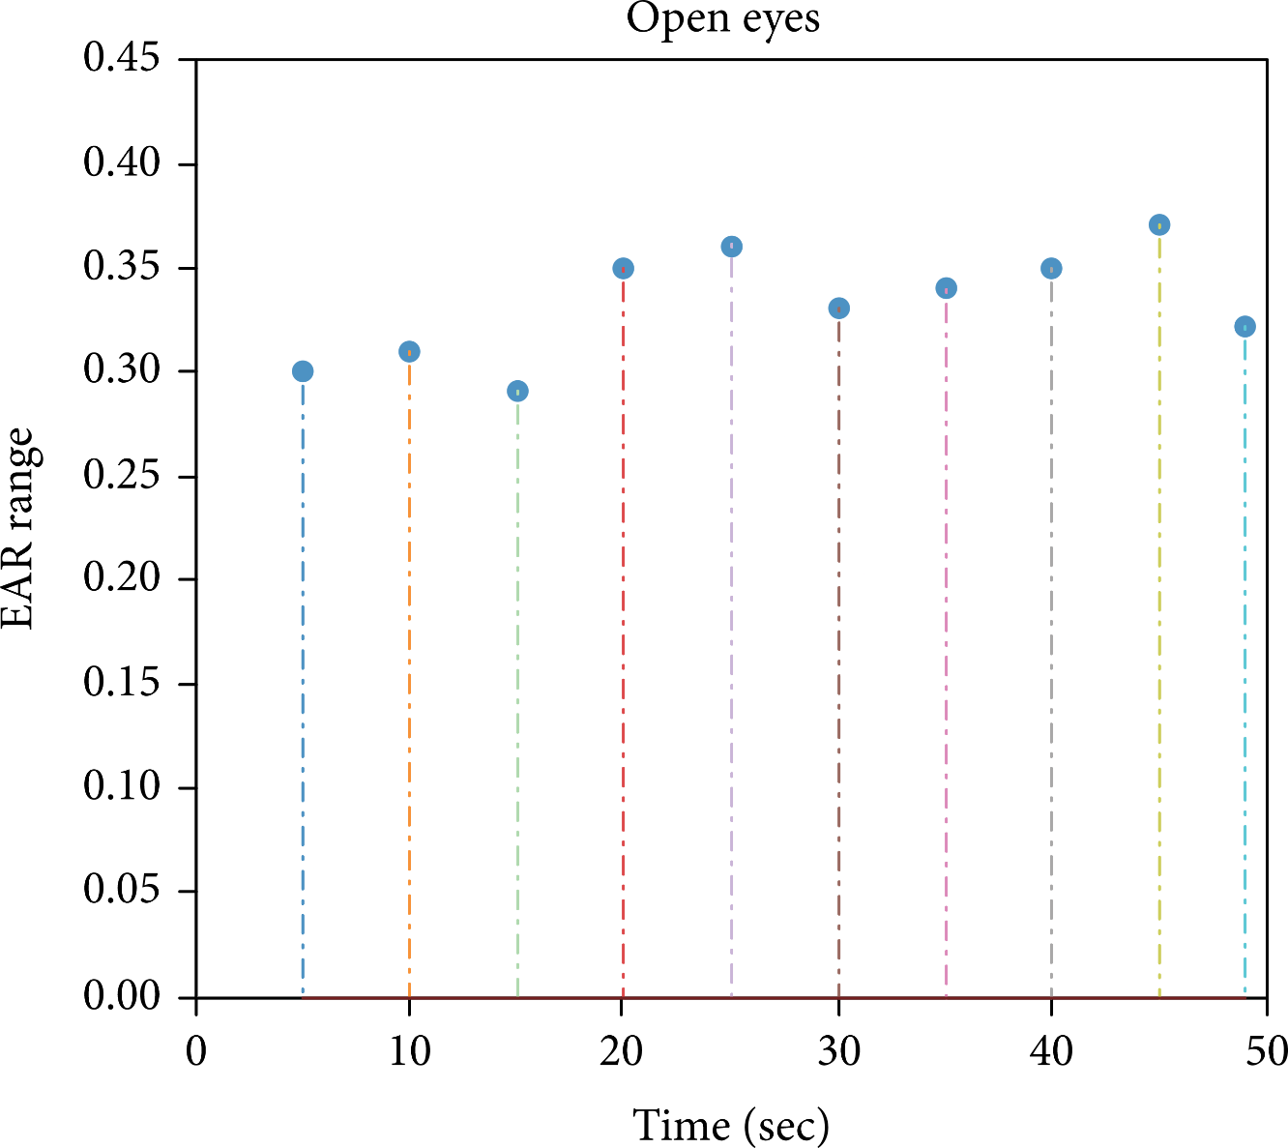

**Figure 4.EAR values vs Time**

From the above figure we can able to say that if the EAR value is greater then the 0.25 it shows that the eyes are open that means the driver is not in the drowsiness state and if the EAR value is less than the 0.25 the driver is in the drowsiness state. The EAR values are changed frequently due to the eyelids. These indicates that if the value is less than 0.25 the alert system will get activated and the alert email as well as the alarm will start ringing.

**5.2 Results and conclusion of existing system**

The most suitable existing system that is find out and the its results about the driver drowsiness detection is as follows:-

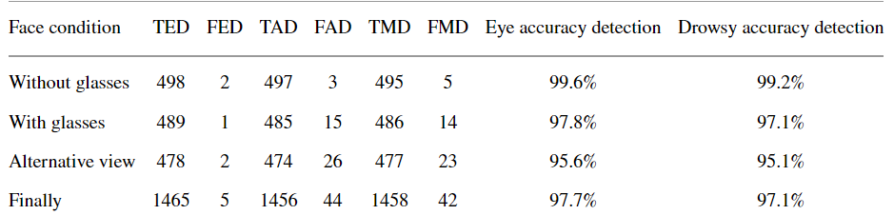

**Table 1. Percentage of drowsiness with various face condition**

From the overall analysis of all the testing we can able to conclude that the using face landmarks does not change under any conditions and its performance is greater than the cascaded method. According to the author of these paper it is says that the system is able to detect the drowsiness using the face landmarks as well as EAR ration with great accuracy. The system checked with a group of people and the accuracy is found to be 97.20% by these system and it is very beneficial to detect the drowsiness.

#### 6. Advantages, Disadvantages and Applications

**6.1 Existing System Advantages / Merits:**

* Wearable Driver Drowsiness Detection System were mobile phone is used as main analysing unit is portable and more flexible to use
* Visualize based system to detect driver drowsiness is convenient for driver as driver don’t need to wear some device while driving.
* In case of different weather conditions system will work fine as infrared camera is used
* By using correct dataset system performance of system is increased.
* No need for human monitoring for detecting driver.

**6.2 Disadvantages:**

* Wearable Driver Drowsiness detection system needs driver to wear electronic device so it is not convenient for driver while driving.
* Visualize based system to detect driver drowsiness is convenient for driver but it increases the cost.
* Weather condition affects the system performance such as light conditions.

**6.3 Applications:**

* Driver Drowsiness Detection system
* Security system for logins for device
* Student attentiveness system
* Attention Management System

**7. Conclusion**

We proposed an approach to generate driver drowsiness detection system with EAR ratio calculation. This has a lot of application as accidents due to driver drowsiness are major issues causing deaths or serious injuries. The techniques used previously have been studied like drowsiness detection by visual assessment, biomedical signals and monitoring vehicle behaviour. Out of which visual assessment to detect drowsiness is more accurate and convenient approach. We have studied this existing system and find some changes that can lead to increase in accuracy of system such as using dataset to train our SVM algorithm so it can give accurate result in case if driver is wearing glasses or their is low intensity light in car. The only drawback of this system is that it increases the cost as we are using infrared camera, so it can work in any weather conditions. For sending the alert system the SMTP(Simple Mail Transfer Protocol) protocol is used to send the alert Email as well as ringing the alarm when the person is detected in drowsiness state. The alert email includes the location of the driver with the help of the GPS module. The system is able to provide with the great accuracy to avoid the drowsiness of the driver.

**8. References**

[1] Iot based Smart Alert System for Drowsy Driver Detection by Anil Kumar Biswal , Debabratra Singh , Binod Kumar Pattanayak , Debabratra Samanta (2021).

[2] Road Accidents Prevention System Using Driver’s Drowsiness Detection by Garima Turan, Shefali Gupta (2013).

[3] Real-Time Drowsiness Detection System For Driver Monitoring by M Arunasalam , N Yaakob , A.Amir , M Elsaikh , N F Azahar (2019).

[4] Arduino based Driver Drowsiness Detection and Alerting System by Debasis Parida (2021).

[5] Driver’s Drowsiness Detection and Alerting System by L.Ramesh , M.Monisha , A.Shirley Pradeeksha (2018).

[6]Drowsiness Detection and Alert System by Jyotsna Gabhane(2018).

[7]Smart Alert System for the Driver’s Drowsiness Detection by Sharath Kumar A J, Sanjana P, Sanjay N, Sanjay K Y, Shreya U Kodgi (2022).

**Plagiarism report of seminar report**

**Plagiarism of report:- 8% plagiarism is detected in the report**

